**Analysis of hurricane intensity (measured by the power dissipation index) and frequency with atmospheric carbon dioxide, sea surface temperature, and the Atlantic Multidecadal Oscillation in the North Atlantic Basin from 1950-2016**

**Group 6**

**Rachel Carr (33941139)**

**Panda Elliott (60214153)**

**Jessica Liu (31819139)**

**Kristine Louie (32283137)**

# 

**Abstract:**

Hurricanes have devastating impacts on the infrastructure of American cities, resulting in billions of dollars in damage and claiming many lives. Considering the recent number of severe tropical storms, there has been much discussion surrounding the possible influence of anthropogenic warming on the formation of these storms. Sea surface temperature (SST) plays a role in tropical cyclone formation; hurricanes are formed when warm water releases heat in spiralling upward winds. The objective of the report is to analyze the correlation between SST and the power dissipation index (PDI) against natural (AMO - Atlantic Multidecadal Oscillation) and manmade forcings (CO2) and to determine the correlation between the number of hurricanes against the same forcings. The region of interest is the North Atlantic Basin (Atlantic Ocean, the Gulf of Mexico and the Caribbean).

Using linear regression, we found that SST was highly correlated and statistically significant with CO2 and the AMO (R2=0.7310 and R2=0.6095, respectively). A multilinear regression for SST, with CO2 and the AMO as the independent variables resulted in a p-value of 1.06E-25 and an R2 value of 0.8905. Using linear regression, we found that the PDI was correlated with SST, CO2 and AMO, resulting in statistically significant p-values (1E-13, 5.1E-5, 4.9E-9, respectively). We also found that the PDI has significantly increased over time (p=~2.39E-4). SST explained the greatest amount of variability in PDI (R2 value=0.5593). Lastly, the number of adjusted hurricanes was found to be correlated with SST, CO2 and AMO. Similarly, SST contributed the most to the variability within the adjusted hurricane data (R2=0.5880). However, we did not find a significant increase in the total number of hurricanes in the North Atlantic Basin from 1950-2013 (p=0.1836).

# Introduction:

In 2005, Hurricane Katrina was the largest and third strongest hurricane recorded to make landfall in the US, killing 1,836 Americans while exceeding an estimated 150 billion dollars in damage in Louisiana and Mississippi (Jorgenson, 2011). This year, Hurricane Harvey broke records for the most amount of rainfall recorded for a tropical storm in US history, described as a 1-in-1,000-year event (Samenow, 2017). In the same hurricane season, Hurricane Irma slammed Florida and the Caribbean islands and Hurricane Maria devastated Puerto Rico. The research surrounding hurricanes is important because a large proportion (39%) of Americans live directly on the shoreline (NOAA1, n.d.). Because of the recent occurrence of severe tropical storms, there has been much discussion between members of the public and climate scientists regarding the possible link between anthropogenic warming and the increase in frequency and severity of tropical hurricanes.

Tropical hurricanes are rotating systems around an area of low pressure originating over subtropical and tropical areas of the ocean. Tropical storms have centres of low pressure which draw in warm, moist air, rotating counter clockwise in the Northern Hemisphere. As the hurricane rotates and pulls in warm air, the air rises rapidly and condenses, releasing large amounts of latent heat energy (NASA, 2017). Hurricanes are categorized according to wind speed (Saffir Simpson scale) as well as pressure, which are inversely related. In our analysis, we used the power dissipation index (PDI) as a measure of hurricane intensity. The PDI is a dimensionless index which combines the frequency, intensity and duration of hurricanes (NOAA2, 2017).

The research regarding the correlations between anthropogenic influence and hurricane formation, like all climate research, is confounded with natural variability cycles. The natural variability cycle which we believe is most relevant to our study and is considered in our analysis is the AMO. The AMO is a climate cycle that affects SST in the North Atlantic Ocean. The oscillations are driven by changes in the Atlantic region of the thermocline circulation, which results in cooler and warmer phases in SST in the Atlantic Ocean, occurring every 60-80 years (McCarthy and Haigh, 2015). Using AMO data, as well as datasets for atmospheric carbon dioxide (CO2), SST, PDI and the number of hurricanes, we will address the following questions in our report:

*Research questions:*

1. What is the strength and significance of the correlation between SST in the North Atlantic Basin and:
2. atmospheric carbon dioxide (CO2) levels
3. AMO
4. both CO2 and the AMO
5. What is the strength and significance of the correlation between the power dissipation index (PDI) and:
6. SST
7. CO2
8. AMO
9. What is the strength and significance of the correlation between the number of hurricanes and:
10. SST
11. CO2
12. AMO
13. Has the number of hurricanes in the North Atlantic basin significantly increased from 1950-2013?
14. Has the PDI for hurricanes in the North Atlantic Basin significantly increased from 1951-2013?

# Methods:

**Table 1.** Dataset Information. This table describes the data of interest as well as the information about source and temporal/spatial range of the dataset. All data were downloaded in .csv format.

|  |  |  |  |
| --- | --- | --- | --- |
| Dataset and description | Source | Temporal/spatial range | Denotation of missing values |
| **CO2**  Mean annual atmospheric carbon dioxide concentration in ppm | National Oceanic & Atmospheric Association (NOAA) - see References - Data sets (1) | Temporal: 1950-2016  Spatial: Mauna Loa Observatory, Hawaii, USA | None missing |
| **SST**  Mean annual sea-surface temperature in Fahrenheit | United States Environmental Protection Agency (EPA) - see References - Data sets (2) | Temporal: 1951-2013  Spatial: North Atlantic Basin (see Figure 1) | None missing |
| **PDI**  Power Dissipation Index, accounting for strength, duration, and frequency of atlantic cyclones (unitless) | EPA - see References - Data sets (2) | Temporal: 1951-2013  Spatial: North Atlantic Basin (see Figure 1) | None missing |
| **Total hurricanes (adjusted)**  Total number of hurricanes by year in the North Atlantic Basin, with adjustments for lack of detection equipment in earlier years | EPA - see References - Data sets (2) | Temporal: 1880-2013 (truncated to 1950-2013)  Spatial: North Atlantic Basin (see Figure 1) | None missing |
| **AMO**  Atlantic Multidecadal Oscillation by month - positive AMO indicates period of warming, negative AMO indicates period of cooling | NOAA - see References - Data sets (3) | Temporal: Monthly values 1856-2017 (truncated to 1950-2016)  Spatial: North Atlantic Basin (see Figure 1) | None missing |

*Description of Data Processing:*

* All datasets were loaded into MATLAB by xlsread() function.
* Using a mask, datasets were truncated into a 1950-2016 time range (where applicable).
* SST data were converted to Celsius since it is the standard measure in Canada.
* Yearly average for AMO data was calculated using a for-loop and mean() function.
* An empty array (76 x 5) was created to compile all truncated datasets together for ease of use in regression/correlation analysis.
  + Using a for-loop, the array was populated by the individual datasets described in Table 1. The first column of the array was for the date vector, populated with years 1950-2016.
  + In cases where the individual datasets did not span the full 76 years studied, empty cells were populated with -999 for ease of masking.

*Description of Data Analysis:*

* Raw data was plotted for each dataset. Simple linear regression was performed for each in order to examine trends over the time period.
* In order to determine the effects of AMO and CO2 on SST, simple linear regression was performed for each, as well as a multilinear regression.
* In order to determine the effects of SST, CO2 and AMO on hurricane frequency (total hurricanes adjusted), simple linear regression was performed for each.
* In order to determine the effects of SST, CO2 and AMO on hurricane intensity (PDI), simple linear regression was performed for each.

**Summary of Results:**

**Table 2.** Simple linear regression results from the SST (°C) for the North Atlantic Basin from 1951-2013. SST is the dependent variable and CO2 (ppm) and AMO are the independent variables. Multilinear regression results for SST as the dependent variable and CO2 (ppm) and AMO as the independent variables.

|  |  |  |  |  |  |
| --- | --- | --- | --- | --- | --- |
| Independent Variable | **SST** vs forcing regression for a: | | | | |
| Simple linear regression | | | | Multilinear regression  (R2 =0.8905, p-value=**\***1.0599E-25) |
| Slope with 95% confidence interval | R2 | R | p-value | Slopes with 95% confidence interval |
| CO2 | 0.0101 °C/ppm (0.0084, 0.0118) | 0.7310 | 0.8550 | **\***9.7792E-17 | 0.0064°C/ppm (0.0050, 0.0078) |
| AMO | 0.9405 °C per unit (0.7477, 1.1332) | 0.6095 | 0.7807 | **\***4.5154E-14 | 0.6610 (0.5085, 0.8134) |

**Table 3.** Simple linear regression results from the PDI for the North Atlantic Basin from 1951-2013. PDI is the dependent variable and SST (°C), CO2 (ppm) and AMO are the independent variables.

|  |  |  |  |  |
| --- | --- | --- | --- | --- |
| Independent Variable | **PDI** vs forcing regression for a simple linear regression | | | |
| Slope with 95% confidence interval | R2 | R | p-value |
| SST | 2.8749 per °C (2.2730, 3.4768) | 0.5993 | 0.7741 | **\***1.0039E-13 |
| CO2 | 0.0227 per ppm(0.0124, 0.0330) | 0.2684 | 0.5181 | **\***5.0904E-5 |
| AMO | 2.9399 (2.0765, 3.8033) | 0.4318 | 0.6571 | **\***4.9299E-9 |

**Table 4.** Simple linear regression results from the total number of hurricanes (adjusted) for the North Atlantic Basin from 1951-2013. Number of hurricanes (adjusted) is the dependent variable and SST (°C), CO2 (ppm) and AMO are the independent variables.

|  |  |  |  |  |
| --- | --- | --- | --- | --- |
| Independent Variable | **Number of hurricanes (adjusted)** vs forcing regression for a simple linear regression | | | |
| Slope with 95% confidence interval | R2 | R | p-value |
| SST | 3.4163 hurricanes per °C (2.6842, 4.1484) | 0.5880 | 0.7668 | **\***2.3501E-13 |
| CO2 | 0.0266 hurricanes per ppm (0.0152, 0.0380) | 0.2935 | 0.5417 | **\***1.9442E-5 |
| AMO | 4.1651 hurricanes per unit (3.2602, 5.0700) | 0.5772 | 0.7598 | **\***3.3722E-13 |

# 

# Discussion:

# *Sea surface temperature*

Figure 2. shows that atmospheric CO2 levels have increased from 1950-2016, with a slope of 1.54 ppm/year. Simultaneously, in Figure 3., SST in the North Atlantic has increased from 1951-2013 with a slope of 0.0098 °C/year. Our analysis shows a strong and significant correlation (R2 =0.7310) between SST and CO2 (Figure 7.) It is well-known that increasing concentrations of greenhouse gases, including carbon dioxide, contribute to the enhanced greenhouse effect. As the majority of the planet’s surface is covered by oceans, the oceans are responsible for absorbing more than 90 percent of the earth excess heat associated with global warming (Stark, 2016). Multilinear regression analysis for SST (dependent variable) with CO2 and AMO (raw data shown in Figure 4.) as external forcings results in a greater R2 value of 0.8905, demonstrating that together, CO2 and the AMO explain a greater amount of variability in the SST in the North Atlantic Basin. Although the multilinear regression model is a good fit for the SST, we cannot conclude whether one variable has greater influence on SST than the other. However, most scientists agree on the contribution of anthropogenic forcing as the dominant cause of the increase in sea surface temperature, as opposed to natural forcing agents or internal climate variability (NOAA2, 2017).

*Hurricane intensity: PDI*

With reference to Figure 5., the PDI has significantly increased (**\***p=2.39E-4) from 1951-2013, indicating that hurricane intensity has increased over time. Our results from linear regression show a significant and positive correlation between PDI and the three independent variables: SST, CO2 and the AMO. The PDI was most strongly correlated with SST (R2 =0.5993 - see Figure 8.) Similar results have been found by Kerry Emanuel, a professor of meteorology at MIT. Emanuel (2005) found a strong correlation between SST and PDI, with an R2 value of 0.75 in the Atlantic Ocean. Although the location is not the North Atlantic Basin, his results provide insight into our analysis. However, Emanuel (2005) found that PDI was less correlated with SST in the Western North Pacific Ocean (R2=0.33), indicating that the correlation between the PDI and SST may vary widely throughout the world’s oceans. Thus, the linear regression model for PDI may serve as a moderate predictor given SST in the Atlantic, but is a poor predictor for locations such as the Western North Pacific. Furthermore, it is well known that there are other environmental factors that have effects on storm intensity and frequency, which include vertical shear of the horizontal wind, relative vorticity, and environmental relative humidity (Emanuel, 2005). Given this, SST alone is not a sufficient predictor of hurricane intensity (Evans, 1993). Future studies, if possible, should incorporate these additional environmental factors with SST to re-evaluate the correlation with PDI.

*Hurricane frequency: total hurricanes (adjusted)*

With regards to the number of hurricanes (adjusted), our analysis does not show any significant change in the total number of hurricanes from 1950-2013 (**\***p=0.1836) in the North Atlantic Basin (see Figure 6.) As well, the number of hurricanes is positively, significantly and moderately correlated (R2=0.5880) to SST (Figure 9.) as well as the AMO (R2=0.5772) and less correlated to CO2 (R2=0.2935). The correlation between the number of hurricanes and SST is slightly stronger than with the AMO. As SST is related to both atmospheric CO2 and the AMO, our study does not provide a model to analyze the combined effect of the three variables.

*Future Scenarios*

The Intergovernmental Panel on Climate Change (IPCC, 2007) predicts that by the end of the 21st century, the SST will rise 1.5°C relative to the SST 1980-1999 average under the B1 scenario. The B1 emission scenarios represent lower estimates of future emission scenarios where society is characterized by high levels of environmental and social consciousness (Nakicenovic, 2000). Using our linear regression model for SST as a predictor of PDI, we calculated the SST average for the Atlantic Basin from 1980-1999 and then added the 1.5°C predicted SST increase by the IPCC, which resulted in a projected SST of 29.27°C in the North Atlantic Basin by 2100. Using our linear regression model, the predicted PDI for this temperature is 6.68, which is higher than the maximum PDI value of ~6 observed from 1951-2013. This maximum PDI value occurred in 2005, which coincides with the year Hurricane Katrina made landfall, the third deadliest and costliest hurricane in US history (University of Rhode Island, 2015). Given our prediction of a PDI value of 6.68 occurring at the end of the 21st century, hurricanes at this level of intensity occurring, hypothetically every year, would be catastrophic. However, our model, given SST alone is not an accurate predictor of PDI, due to the effect of other environmental factors mentioned previously.

Hopefully, our report demonstrates that the research surrounding hurricane formation and the role of anthropogenic influence is complex. NOAA’s projects that the frequency of hurricanes in the North Atlantic will not increase, and states with medium confidence that hurricanes will be more intense on average. Global projections by NOAA estimated that anthropogenic warming will likely cause hurricanes to be more intense on average (by 2-11%), resulting in a greater destructive potential per storm with higher than average rainfall rates (NOAA2, 2017). Given this information, the global projections are alarming. An increase in average hurricane intensity of, say 10% (within the model prediction of NOAA) is significant and would result in considerably more damage from hurricanes. It is clear that large changes must be made to safeguard the American population, and other populations living along the coast from possible increases in severe storms predicted to occur near the end of the 21st century.

# Conclusion:

Through our investigation on hurricane intensity and frequency given data on SST, PDI and the AMO, we found a strong and statistically significant correlation between SST and CO2 (R2=0.7310) . The correlation between SST and AMO is also statistically significant (**\***p=4.52E-14), albeit with a smaller coefficient of determination value (R2=0.61). Using multilinear regression, with CO2 and AMO as the two predictors against SST, we obtained an R2 value of 0.8905 and a p-value of **\***1.1E-25. Thus, CO2 and AMO together explain a greater amount of variability in SST in the North Atlantic Basin.

Furthermore, using linear regression, we found that the PDI was significantly and positively correlated with SST, CO2 and the AMO (**\***p=1E-13, 5.1E-9, **\***4.93E-9, respectively). The linear regression model for PDI and SST produced the highest R2 value (0.5993), which suggests that out of the three variables studied, SST is responsible for the most variance in PDI over time. We also found that the PDI (our measure of hurricane intensity) has significantly increased over time (**\***p=2.39E-4).

Lastly, using linear regression, we found that the correlation between the number of hurricanes (adjusted) and SST, CO2 and AMO was statistically significant. The correlation was found to be the highest for SST (R2=0.5880), followed by AMO (R2=0.5772) and finally CO2 (R2=0.2935). However, we did not find a significant change in the number of hurricanes from 1950-2013 (p=0.1836).

# References

Emanuel, K. (2005, August 4). Increasing destructiveness of tropical cyclones over the past 30 years. *Nature, 436*, pp. 686-688. Doi:10.1038/nature03906

Evans, J.L. (1993 June). *Sensitivity of Tropical Cyclone Intensity to Sea Surface Temperature*. American Meteorological Society.[*https://doi.org/10.1175/1520-0442(1993)006*](https://doi.org/10.1175/1520-0442(1993)006)[*<1133:SOTCIT>2.0.CO;2*](https://doi.org/10.1175/1520-0442(1993)006%3C1133:SOTCIT%3E2.0.CO;2)

IPCC. (2007). *6.3.2 Climate and sea-level scenarios*. Retrieved from <https://www.ipcc.ch/publications_and_data/ar4/wg2/en/ch6s6-3-2.html>

Jorgenson, Ellen. (2011). *Hurricane Katrina: Humanitarian Obligations and Lessons Learned*. Retrieved from <https://www.du.edu/korbel/crric/media/documents/ellenjorgenson.pdf>

McCarthy, Gerard & Haigh, Ivan. (2015, May 29). *The Atlantic is entering a cool phase that will change the world’s weather*. Retrieved from <https://theconversation.com/the-atlantic-is-entering-a-cool-phase-that-will-change-the-worlds-weather-42497>

Nakicenovic, Nebojsa & Swart, Rob. (2000). *Emissions Scenarios*. Retrieved from <http://www.ipcc.ch/ipccreports/sres/emission/index.php?idp=94>

NASA. (2017). *How do hurricanes form?* Retrieved from<https://spaceplace.nasa.gov/hurricanes/en/>

NOAA1. (n.d.) *What percentage of the American population lives near the coast?* Retrieved from<https://oceanservice.noaa.gov/facts/population.html>

NOAA2. (2017, October 26). *Global warming and hurricanes*. Retrieved from <https://www.gfdl.noaa.gov/global-warming-and-hurricanes/>

Samenow, Jason. (2017, August 31). *Harvey is a 1,000-year flood event unprecedented in scale*. Retrieved from<https://www.washingtonpost.com/news/capital-weather-gang/wp/2017/08/31/harvey-is-a-1000-year-flood-event-unprecedented-in-scale/?utm_term=.1fa961a92a26>

Stark, Anne. (2016, January 18). Livermore scientists find global ocean warming has doubled in recent decades. Retrieved from <https://www.llnl.gov/news/livermore-scientists-find-global-ocean-warming-has-doubled-recent-decades>

University of Rhode Island. (2015). *Hurricanes: Science and Society: Katrina Impacts*. Retrieved from <http://www.hurricanescience.org/history/studies/katrinacase/impacts/>

Data Sets:

1. ESRL Global Monitoring Division - Global Greenhouse Gas Reference Network. (2005). *ESRL CO2 Trends RSS* [Data file]. Retrieved from <https://www.esrl.noaa.gov/gmd/ccgg/trends/>

2. EPA. (2016). *Climate Change Indicators: Tropical Cyclone Activity* [Data file]. Retrieved from <https://www.epa.gov/climate-indicators/climate-change-indicators-tropical-cyclone-activity>

3. ESRL Physical Sciences Division. [Data file]. Retrieved from <https://www.esrl.noaa.gov/psd/data/correlation/amon.us.long.data>

# 

# 

# Figures:

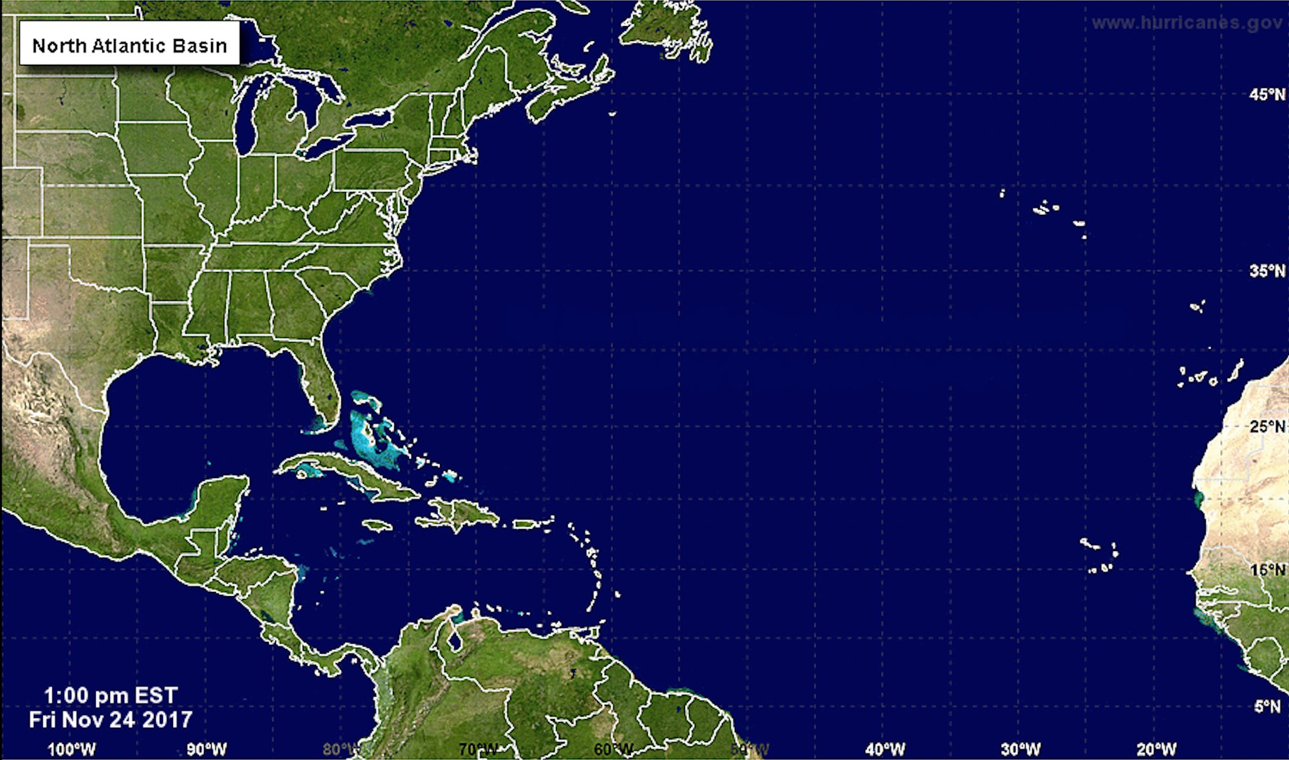

**Figure 1.** Map of the North Atlantic Tropical Basin

Figure retrieved and modified from: Pope, John (2014, September 7). *National Hurricane Center tracking two storms off Africa's coast*. Retrieved from <http://www.nola.com/hurricane/index.ssf/2014/09/national_hurricane_center_trac.html>

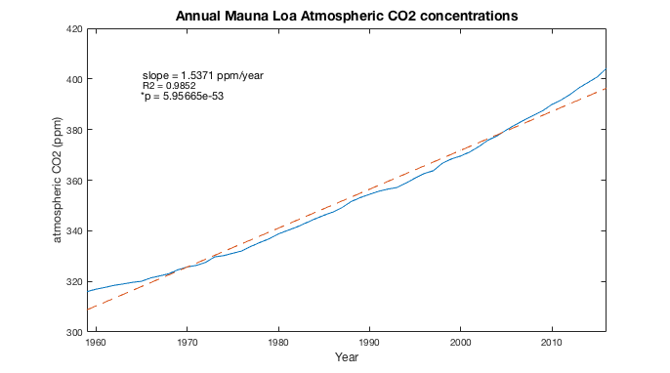

**Figure 2.** AnnualMauna Loa carbon dioxide levels (ppm) from 1959-2016 with a linear regression model. The data was obtained from the National Oceanic and Atmospheric Administration, Global Monitoring Division. The data has a slope of 1.5371 ppm/year with a coefficient of determination value of 0.9852.

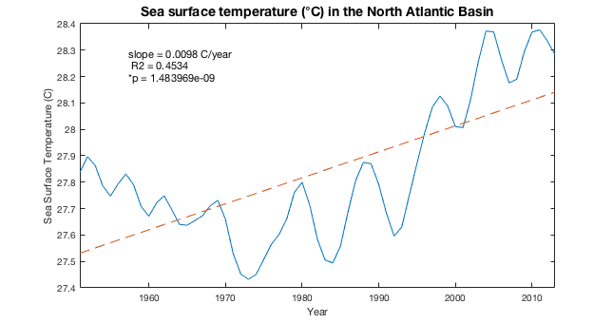

**Figure 3.** Sea surface temperature (°C) in the North Atlantic Basin from 1951-2013. Sea surface temperature data obtained from the United States Environmental Protection Agency (EPA). The sea surface temperature data has a slope of 0.0098 °C/year, with a coefficient of determination value of 0.4534.

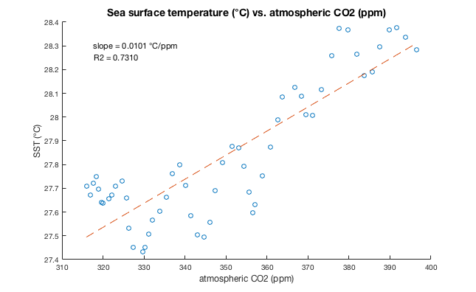

**Figure 7.** Correlation for SST (°C) and atmospheric CO2 (ppm)in the North Atlantic Basin using a linear regression model. The slope is 0.0101 °C/ppm with a coefficient of determination of 0.7310. The p-value is *9.8e-17.

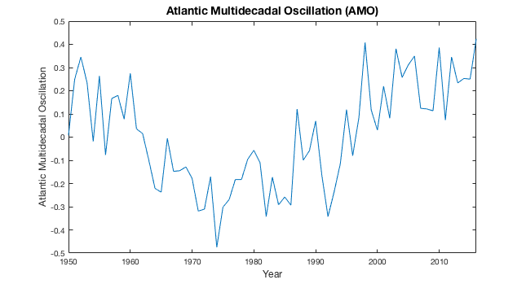

**Figure 4.** The Atlantic Multidecadal Oscillation from 1950 to 2016. The AMO is a natural variability cycle where the North Atlantic Ocean experiences warm and cold periods, with cycles occurring every 60-80 years (AMO, n.d.).

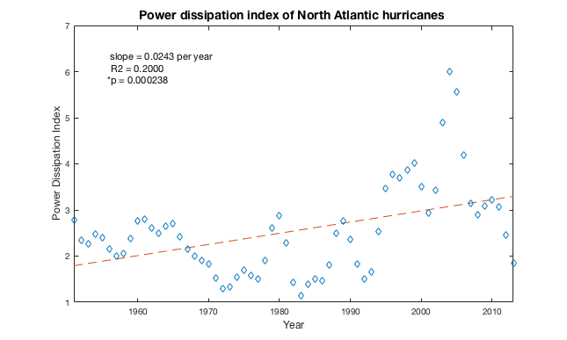

**Figure 5.** Power Dissipation Index of hurricanes in the North Atlantic Basin from 1951-2013. The data was obtained from the EPA. The slope is 0.0243 per year with a coefficient of determination of 0.2.

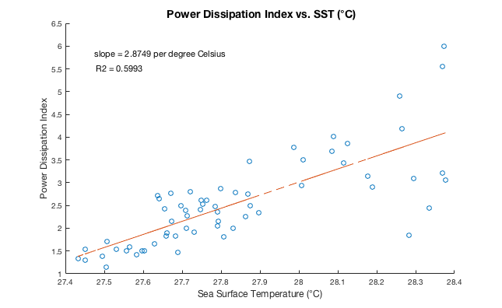

**Figure 8.**  Correlation for the PDI and SST (°C) for North Atlantic Basin hurricanes from 1951-2013 using simple linear regression. The slope is 2.8749 per °C with a coefficient of determination of 0.5993 The p-value is *1.0038e-13.

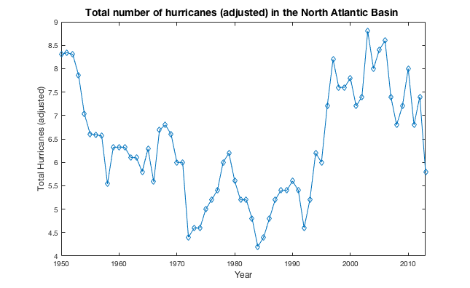

**Figure 6.** Total number of hurricanes in the North Atlantic Basin adjusted to account for the lack of renaissance aircraft data and satellite observations in early years from 1950-2013. The data was taken from NOAA’s revised hurricane data. The p-value from the linear regression model (not shown) is 0.1836.

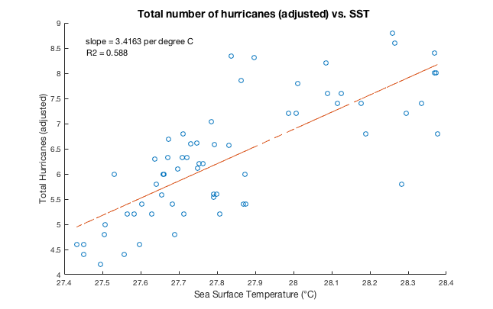

**Figure 9.** Correlation fortotal number of hurricanes in the North Atlantic Basin adjusted for measurement errors vs. sea surface temperature from 1950-2013 using simple linear regression. The slope is ~3.42 per °C with a coefficient of determination of 0.588. The p-value is *2.35010e-13.